**Aim** :- Run containers on a managed service.

**Lab overview and objectives**

In a previous lab, you migrated an application that ran on Amazon Elastic Compute Cloud (Amazon EC2) instances to run on Docker containers. In this lab, you will deploy the application using two managed cloud services. You will deploy the database tier using Amazon Aurora Serverless and the web tier using AWS Elastic Beanstalk.

After completing this lab, you should be able to:

* Create a new Amazon Relational Database Service (Amazon RDS) instance using the AWS Management Console
* Launch a Docker container on an IDE using an image pulled from Amazon Elastic Container Registry (Amazon ECR)
* Configure and test the containerized application connection to Aurora Serverless
* Use the Amazon RDS query editor to create database objects and load data
* Launch the default Elastic Beanstalk application
* Update the Elastic Beanstalk application to run your node application and communicate with Amazon RDS
* Configure an Amazon API Gateway endpoint to forward calls to the Elastic Beanstalk URL

**AWS service restrictions**

In this lab environment, access to AWS services and service actions might be restricted to the ones that are needed to complete the lab instructions. You might encounter errors if you attempt to access other services or perform actions beyond the ones that are described in this lab.

**Scenario**

Sofía has containerized the coffee suppliers application. Now the café has asked if she can reduce the required manual application maintenance and plan for the future scalability of the environment. She knows from her studies that Amazon Web Services (AWS) provides several managed services. Managed services can help to reduce the burden of deploying and managing applications. After more research, she has decided to deploy the suppliers application website using Elastic Beanstalk.

However, Sofía has discovered that scaling a relational database using containers is not recommended because relational databases are stateful. Relational databases require reliable communication between database hosts and storage. This is difficult to accomplish using dynamic containers. Therefore, Sofía has decided to use Aurora Serverless as the data platform. Sofía will retire the container-based MySQL database and load the required user, tables, and data into an Aurora Serverless database. Aurora Serverless was designed to seamlessly and safely scale databases as transaction loads increase. As a bonus, when the database isn't being used, Aurora Serverless automatically scales down, which will save money for the café.

In this lab, you will again play the role of Sofía, and you will deploy the suppliers application using managed services.

**Task 1: Preparing the lab**

Connect to the VS Code IDE.

1. At the top of these instructions, choose Details followed by **AWS: Show**
2. Copy values from the table **similar** to the following and paste it into an editor of your choice for use later.
   1. **LabIDEURL**
   2. 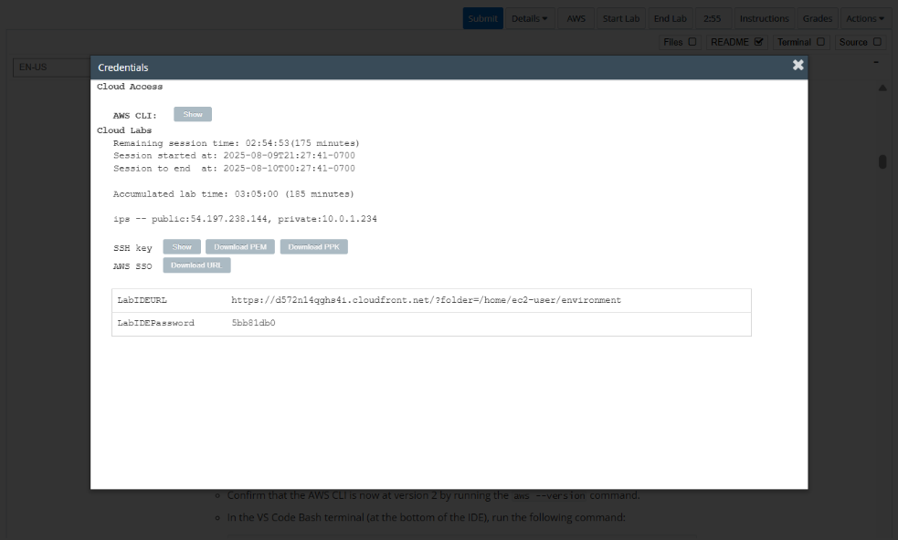**LabIDEPassword**
3. In a new browser tab, paste the value for **LabIDEURL** to open the VS Code IDE.
4. On the prompt window **Welcome to code-server**, enter the value for **LabIDEPassword** you copied to the editor earlier, choose **Submit** to open the VS Code IDE.

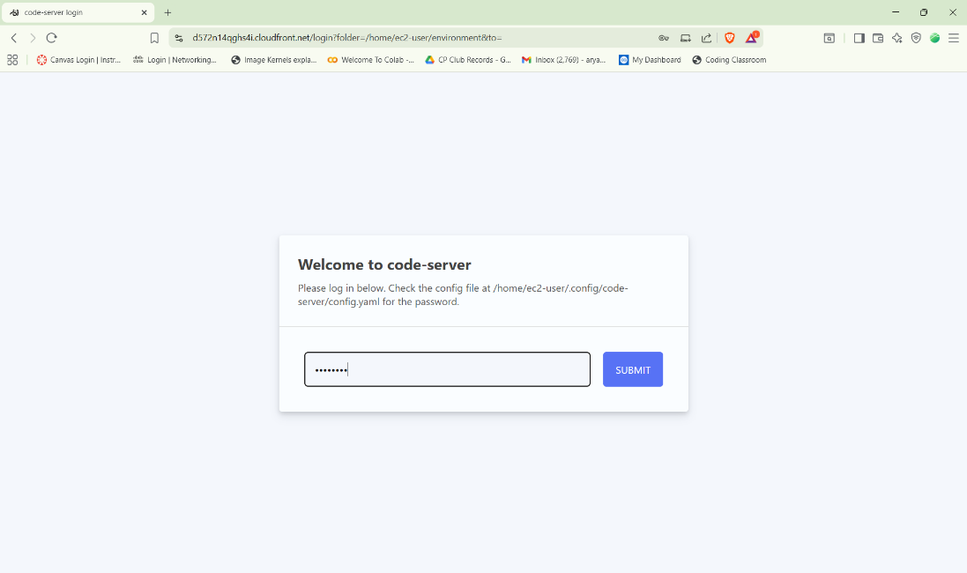

1. Download and extract the files that you need for this lab.

* In the VS Code bash terminal (located at the bottom of the IDE), run the following commands:

**wget https://aws-tc-largeobjects.s3.us-west-2.amazonaws.com/CUR-TF-200-ACCDEV-2-91558/07-lab-deploy/code.zip -P /home/ec2-user/environment**

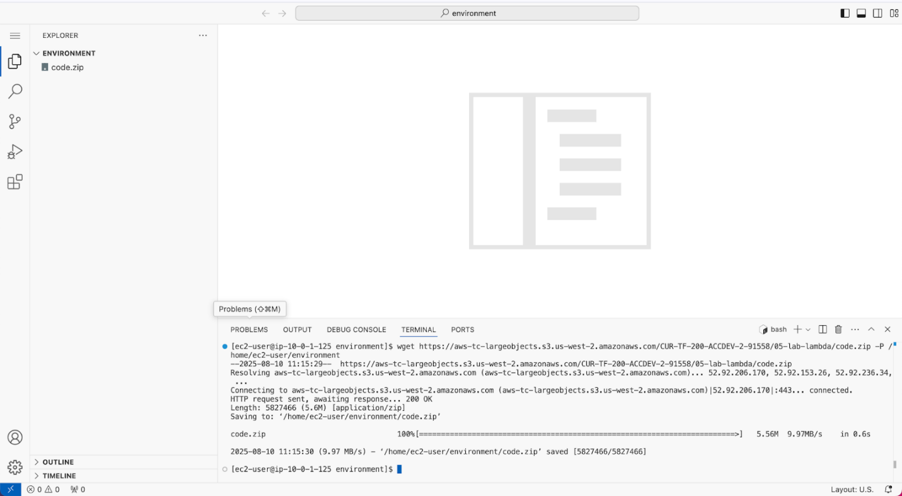

1. You should see that the **code.zip** file was downloaded to the VS Code IDE and is now in the left navigation pane.

* Extract the file by running the following command:

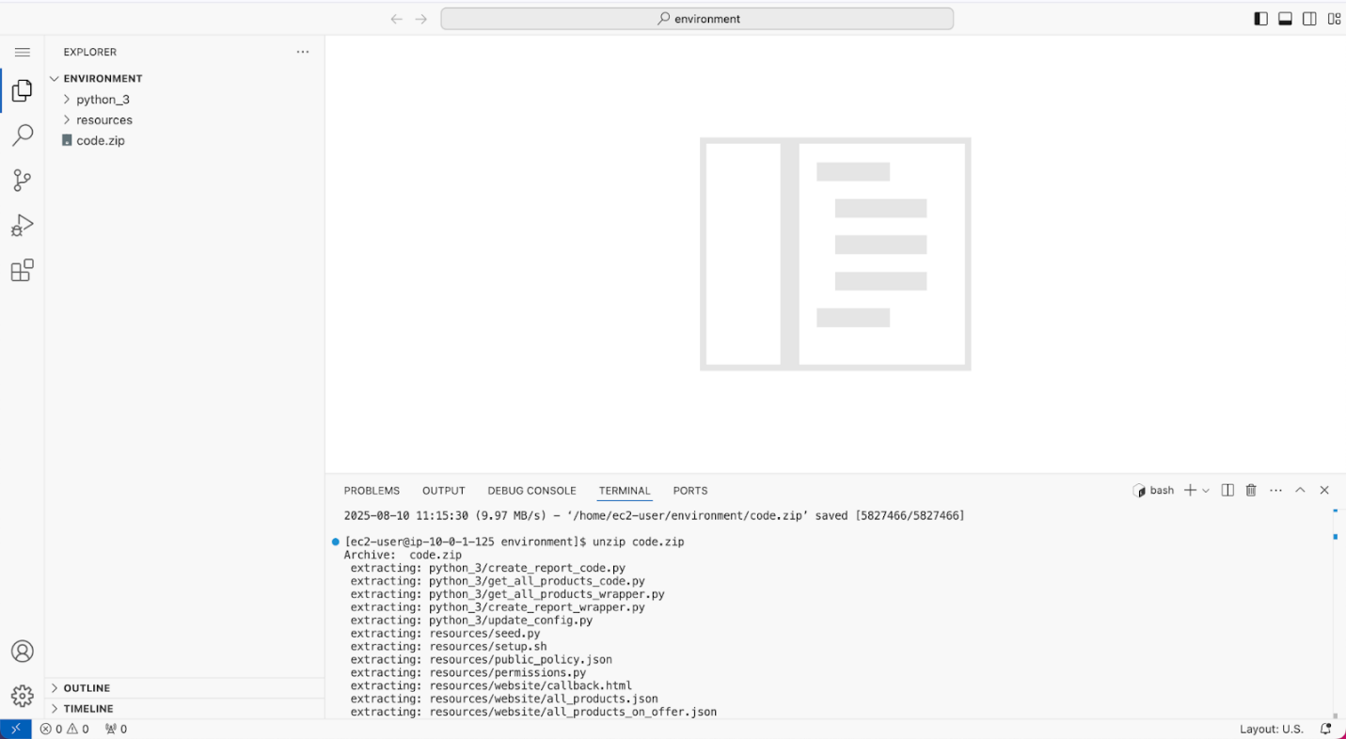unzip code.zip

1. Run a script that upgrades the version of the AWS CLI installed on the VS Code IDE.

* To set permissions on the script and then run it, run the following commands in the Bash terminal:

chmod +x ./resources/setup.sh && ./resources/setup.sh

The script will prompt you for the **IP address** by which your computer is known to the internet.

Use [www.whatismyip.com](http://www.whatismyip.com/) to discover this address and then paste the IPv4 address into the command prompt and finish running the script.

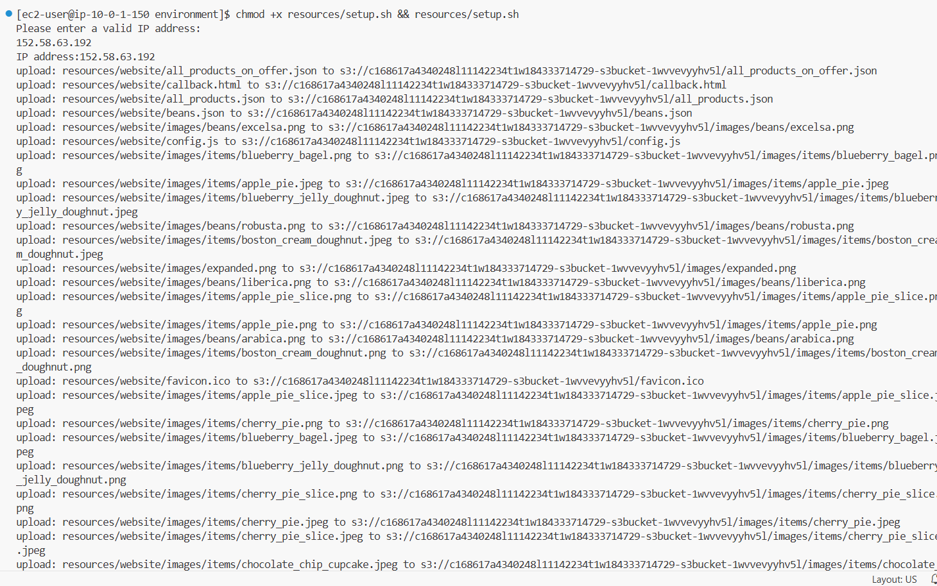

1. Verify the AWS CLI version and also verify that the SDK for Python is installed.

* Confirm that the AWS CLI is now at version 2 by running the **aws --version** command.
* In the VS Code Bash terminal (at the bottom of the IDE), run the following command:

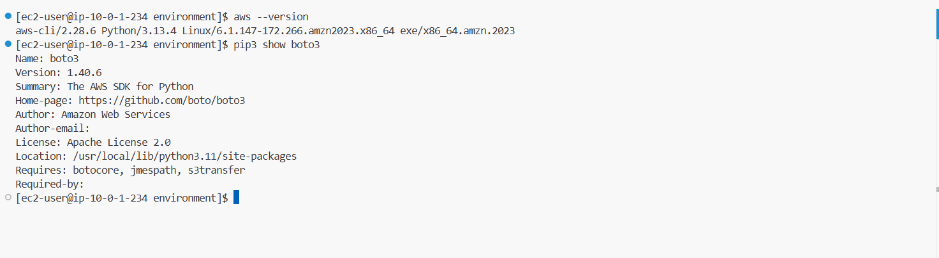**pip3 show boto3**

1. Confirm access to the café website.

* Navigate to the Amazon S3 console.
* Choose the link for the bucket that has *-s3bucket* in the name.
* Choose the **Properties** tab, then scroll down to the Static website hosting section.
* Choose the URL that appears under Bucket website endpoint.
* 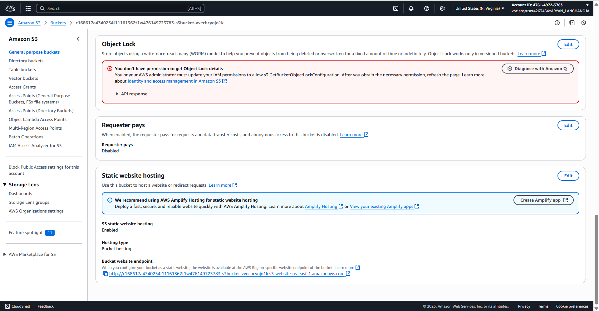The café website displays in a new browser tab. If it doesn't, see the following troubleshooting tip.

1. Open your preferred text editor, and copy and paste the following text into a new file.

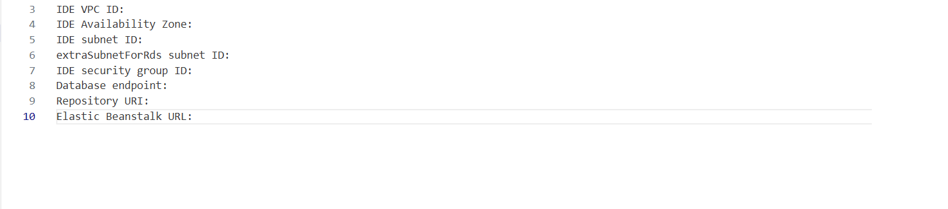

**Task 2: Configuring the subnets for Amazon RDS and Elastic Beanstalk to use**

1. Navigate to the Amazon VPC console.
   * Return to the AWS Management Console browser tab.
   * From the **Services** menu, choose **VPC**.
   * In the left navigation pane, choose **Your VPCs**.
   * 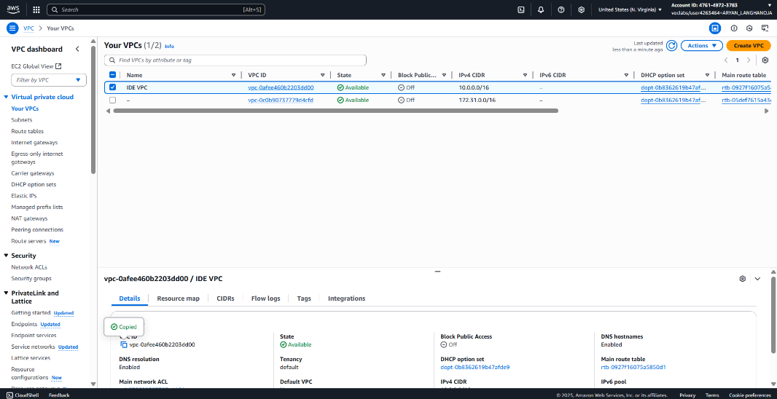Select the checkbox for *IDE VPC*, and then copy the **VPC ID** into your text editor.
2. Review the Availability Zone for the *IDE Subnet*.
   * In the left navigation pane, choose **Subnets**.
   * Select the checkbox for *IDE Public Subnet One*.
   * In the bottom pane, locate the **Availability Zone** and copy the value into your text editor.

The Availability Zone looks similar to the following: *us-east-1a*

* + Copy the **Subnet ID** value into your text editor as the **IDE Subnet ID**.

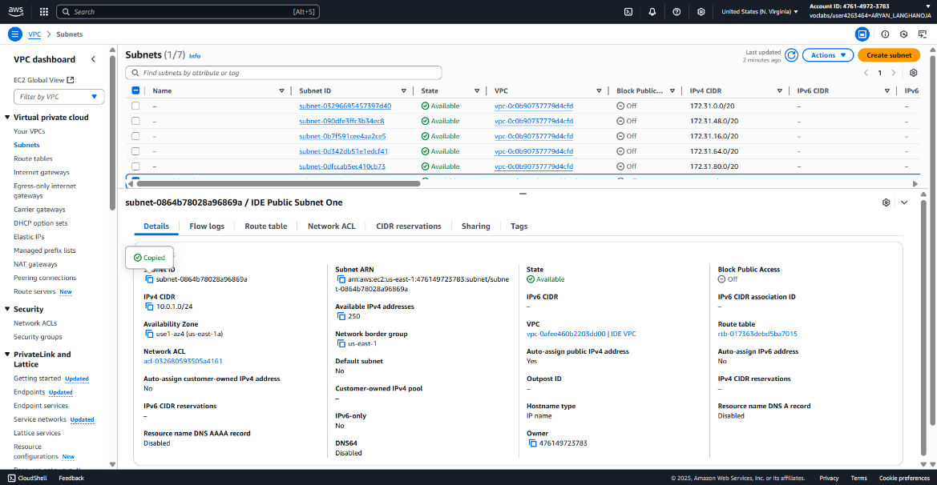

1. Create a second subnet to provide high availability for the database and application in the future:
   * Choose **Create subnet** and configure the following:
     + **VPC ID:** Choose **IDE VPC**
   * **Subnet name:** Enter extraSubnetForRds
     + **Availability Zone:** Choose a different Availability Zone than the one that the *IDE Subnet* is using
   * **IPv4 CIDR block:** Enter 10.0.2.0/24
     + Choose **Create subnet**.
   * Configure the subnet to automatically assign a public IP address:
     + Select the checkbox for *extraSubnetForRds*.
     + From the **Actions** menu, select **Edit subnet settings**.
     + Select the checkbox for **Enable auto-assign public IPv4 address**.
     + Choose **Save**.
   * In a text editor, record the **Subnet ID** as the **extraSubnetForRds subnet ID**.

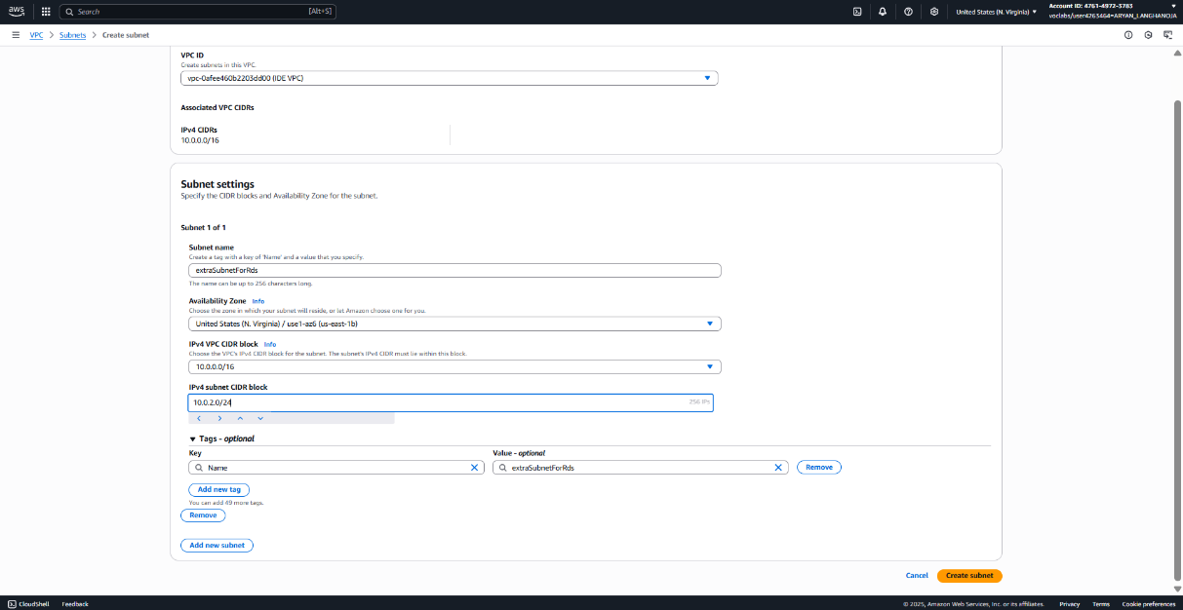

1. Update the route table for the *extraSubnetForRds* subnet.

* Select the checkbox for *extraSubnetForRds*.
* In the bottom pane, choose the **Route table** tab, and review the route table.
  + Notice that this route table does not include a path to the public internet (0.0.0.0/0). For this configuration to work, you need to update the route table association for this subnet.
* Choose **Edit route table association**.
  + The subnet is currently configured to use the *Main route table*.
* For **Route table ID**, choose the other route table.
* Choose **Save** then choose the **Route table** tab.

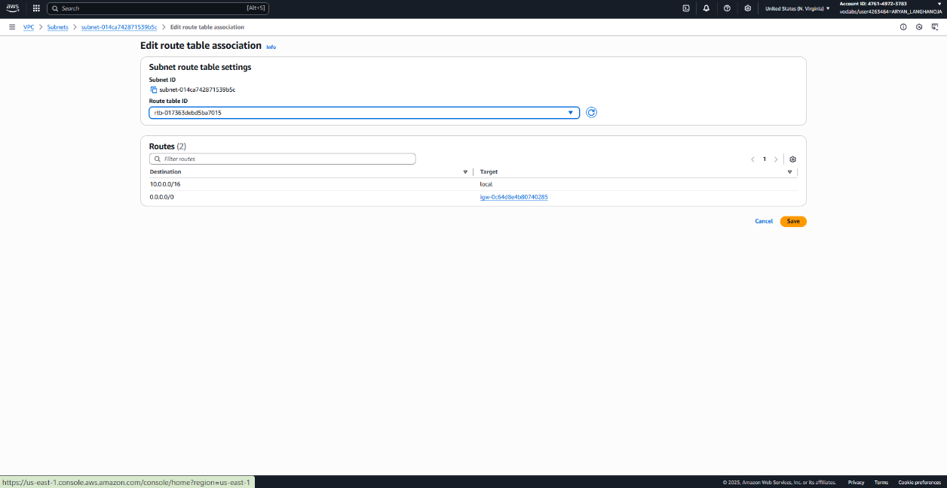

**Task 3: Setting up an Aurora Serverless database**

Instead of running the database on an EC2 instance or in a Docker container, the application will use the Aurora Serverless managed service as the data platform.

In this task, you will create a new Aurora Serverless instance.

1. Create an Aurora Serverless database instance.

* In the search box to the right of **Services**, search for and choose **RDS**.
* In the Create database panel under the Resources panel, choose **Create database**.
  + In the **Choose a database creation method** section, choose **Standard create**.
  + In the **Engine options** section, configure the following:
  + **Engine type:** Choose **Aurora(MySQL-Compatible)**
  + **Version:** Choose **Aurora MySQL 3.07.0 (compatible with MySQL 8.0.36)**
  + In the **Templates** section, choose **Dev/Test**.
  + In the **Settings** section, configure the following:
    - **DB cluster identifier:** Enter supplierdb
  + Under **Credentials management**, choose **Self managed**.
  + Ensure that **Auto generate a password** is NOT checked
  + **Master password:** Enter coffee_beans_for_all

📓 **Note:** This is the password for the database super user that is named *admin*. You will use this password later in this assignment.

* + **Confirm password:** Re-enter the password
  + In the **Instance configuration** section, configure the following:
    - **DB instance class:** Choose **Serverless v2**
  + Also note the default **Capacity range** settings (Minimum 2 ACU, Maximum 16 ACU) but do not change them.
  + In the **Connectivity** section, configure the following:
    - **Virtual Private Cloud (VPC):** Choose **IDE VPC**
    - Under **VPC security group (firewall)**, choose **Existing VPC security groups**
    - Remove the **default** security group
    - From the Dropdown, add the security group with **Lab IDE** in the name
  + Under **RDS Data API**, Select Checkbox for *Enable the RDS Data API*.
  + Under **Monitoring > Performance Insights**
    - **UnCheck/DeSelect** *Enable Performance Insights (cluster level)*
    - Expand **Additional configuration (Enhanced Monitoring)**
      1. **Uncheck/DeSelect** *Enable Enhanced Monitoring*
  + Expand **Additional configuration**
  + For **Initial database name**, enter suppliers
  + 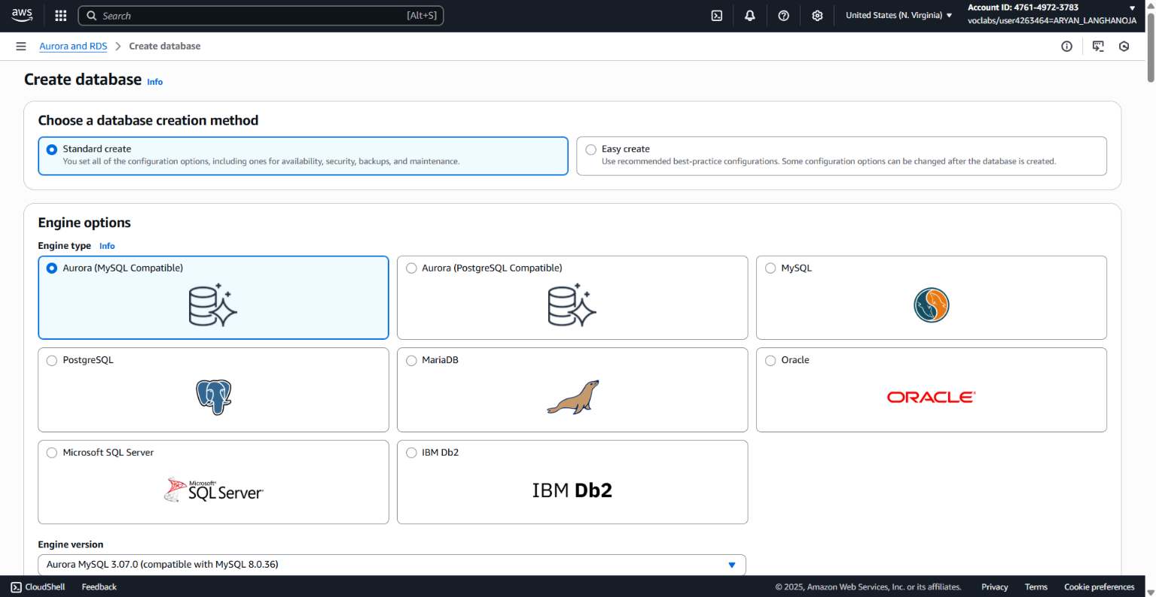Keep rest of the parameters at their default values and Choose **Create database**.

1. Find the endpoint for your database.

* Choose the **supplierdb** hyperlink displayed at the top.
* From the **DB identifier** , select **supplierdb-instance-1**.
  + **Note:** Wait for the Status to become *Available*.
* On the In the bottom pane, in the **Connectivity & security** section
  + Copy the **Endpoint** value to your text editor.

The endpoint is similar to *supplierdb.cluster-xxxxxxxxxxx.us-east-1.rds.amazonaws.com*.

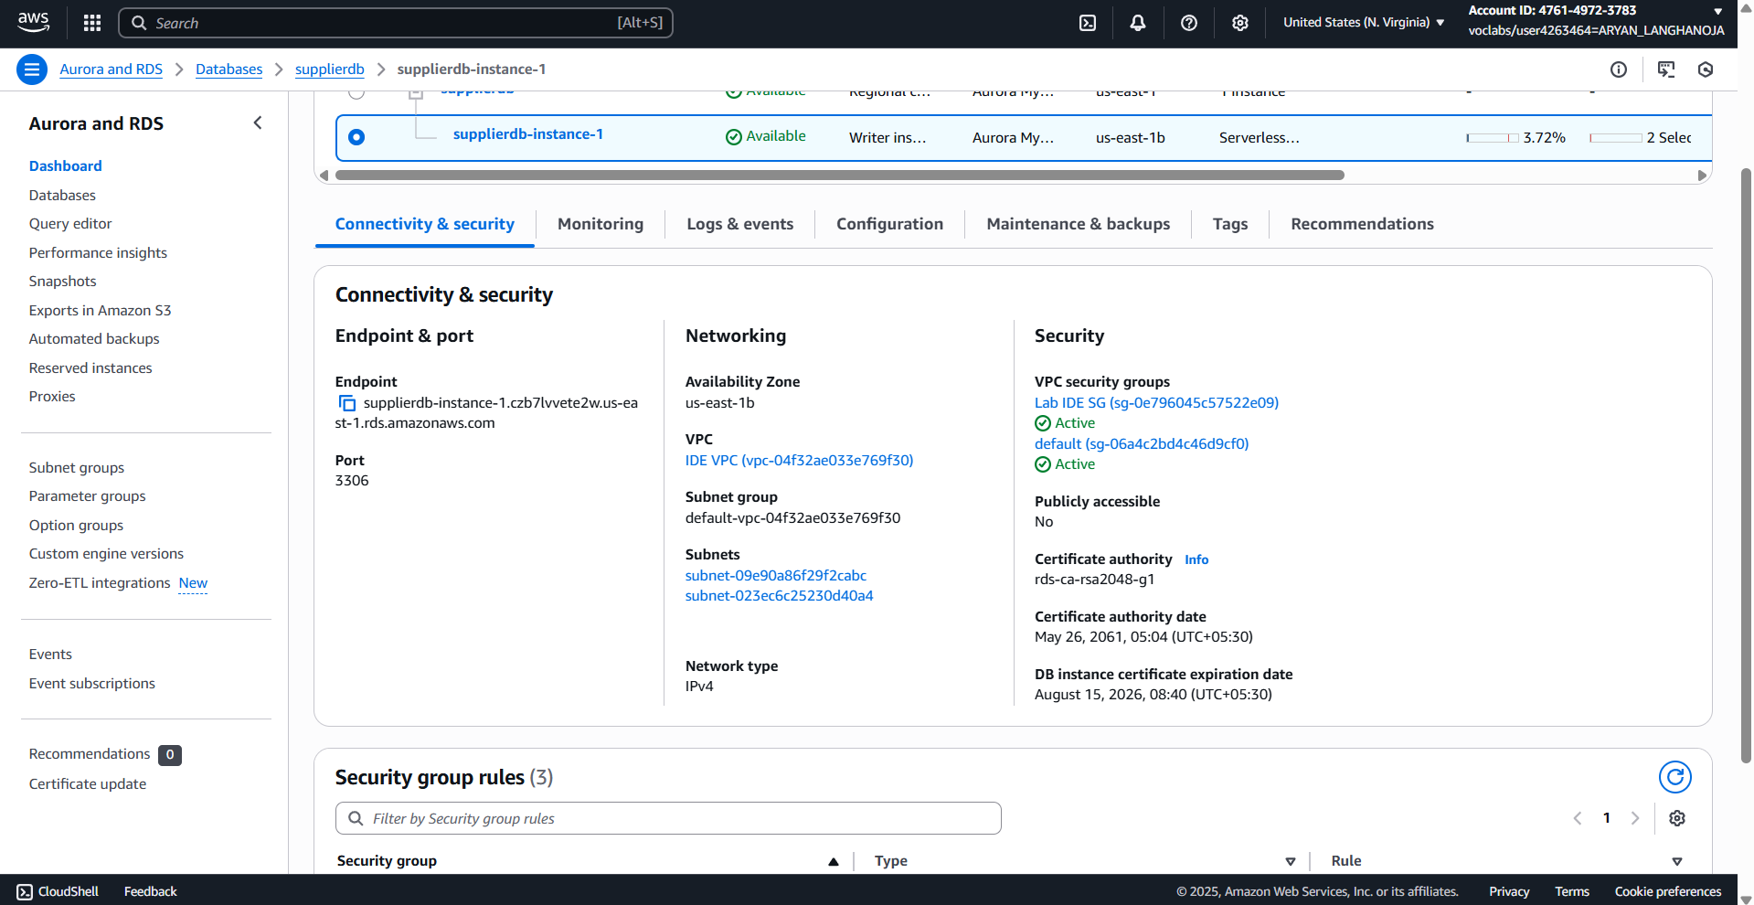

1. Find the ID for the database security group.

* In the **Security** section, choose the **VPC security groups** hyperlink.
* On the **Security Groups** page, in the bottom pane, on the **Details** tab, copy the **Security group ID** value to your text editor.
* The security group ID is similar to *sg-123456acbde*.

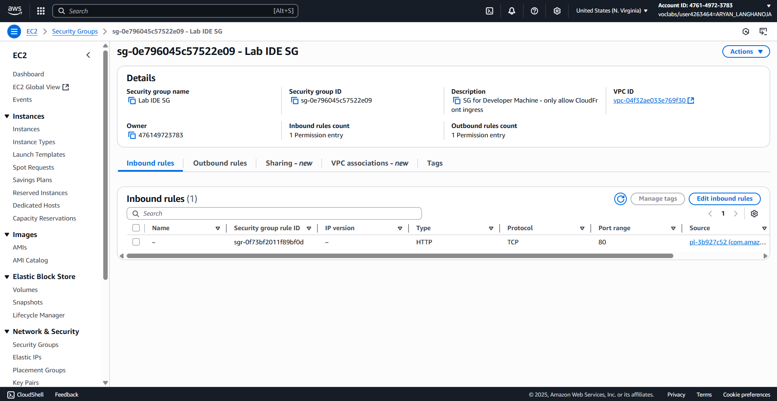

**Task 4: Reviewing the container image**

1. Review the Docker image in the console.

* In the search box to the right of Services, search for and choose Elastic Container Registry.
* For the cafe/node-web-app repository, copy the URI value to your text editor as the Repository URI.
* 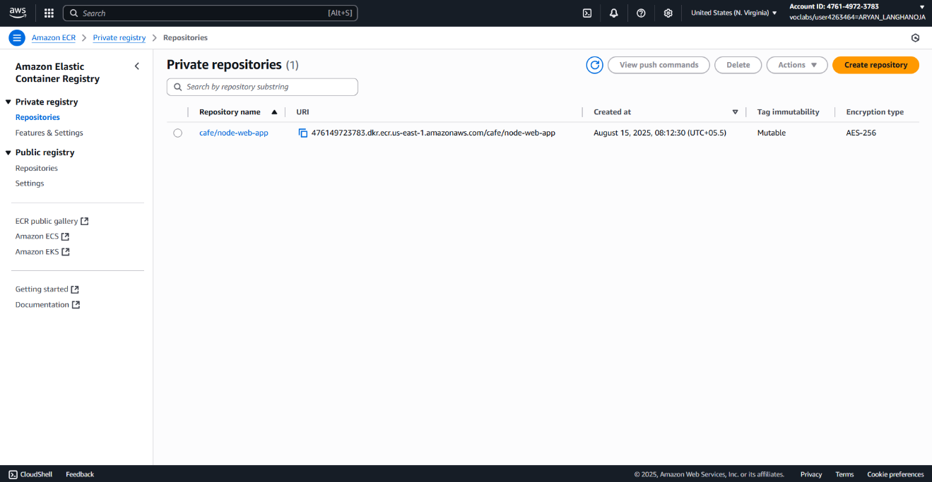Choose the cafe/node-web-app hyperlink, and review the details

1. Review this same Docker image information in the VS Code bash terminal.

* Return to the VS Code IDE browser tab.
* Run the following command:

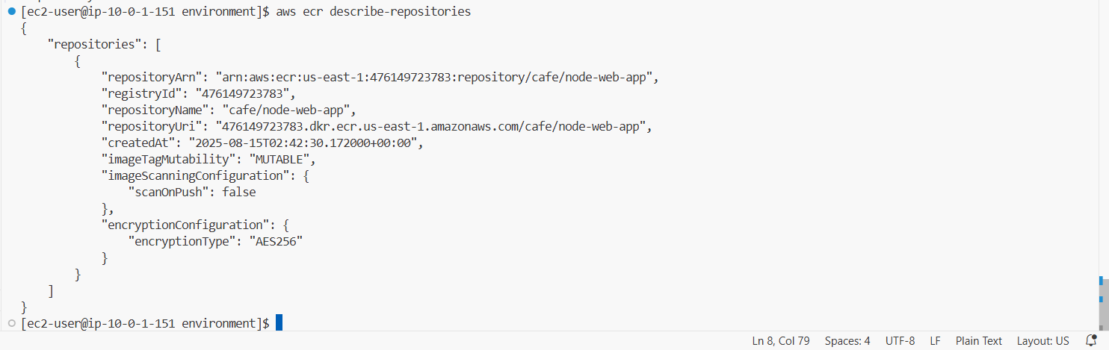**aws ecr describe-repositories**

1. Next, to inspect the *cafe/node-web-app* image, run the following command in the VS Code bash terminal:

**aws ecr describe-images --repository-name cafe/node-web-app**

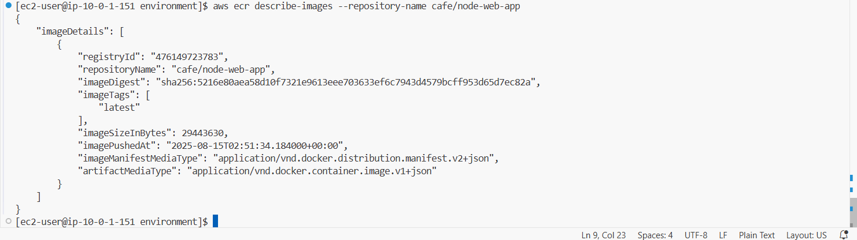

**Task 5: Configuring communication between the container and the database**

1. Start your container.

* In the VS Code bash terminal, enter the following command. Replace **<db-endpoint>** with the **Database endpoint** value from your text editor.

**docker run -d --name node-web-app-1 -p 8000:3000 -e APP_DB_HOST=" supplierdb-instance-1.czb7lvvete2w.us-east-1.rds.amazonaws.com" cafe/node-web-app**



1. To test the container application from the VS Code bash terminal, run the following command:

**curl http://localhost:8000**

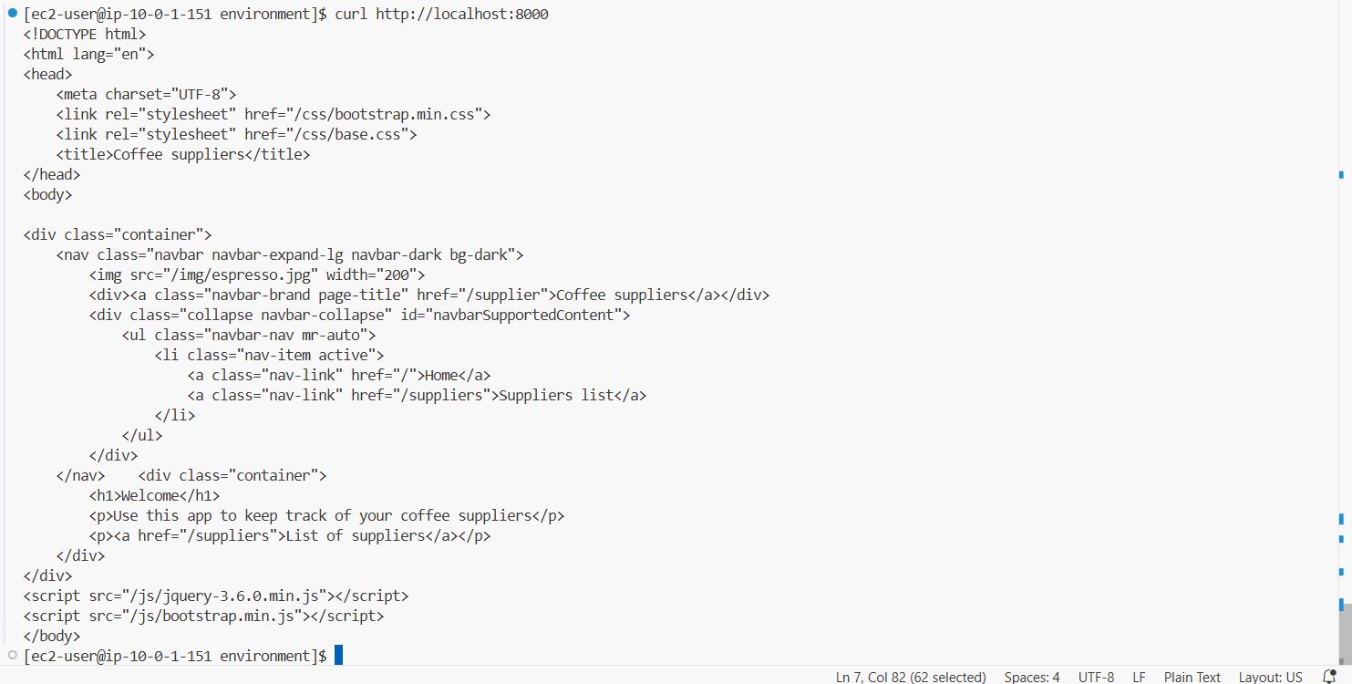

1. Configure the security group of the VS Code IDE EC2 instance.

As in a previous lab, you need to add a rule so that you can view the website on port 80:

* Return to the AWS Management Console browser tab.
* In the search box to the right of **Services**, search for and choose **EC2**.
* In the left navigation pane, choose **Security Groups**.
* Select the checkbox for the security group that has *Lab IDE SG* in the name.
* In the lower pane, choose the **Inbound rules** tab.
* Choose **Edit inbound rules**.
* Add an entry for the application port:
  + Choose **Add rule**
  + **Type:** Choose **Custom TCP**
  + **Port range:** 8000
  + **Source:** Choose **My IP**

Add an entry for the database port:

* Choose **Add rule**
* **Type:** Choose **MYSQL/Aurora**
* **Source:** Choose **Custom**
* From the **Source** search box, choose the *Lab IDE SG* security group that you are currently editing.

This rule is self referencing to allow any call that originates from this security group to communicate with the database.

* 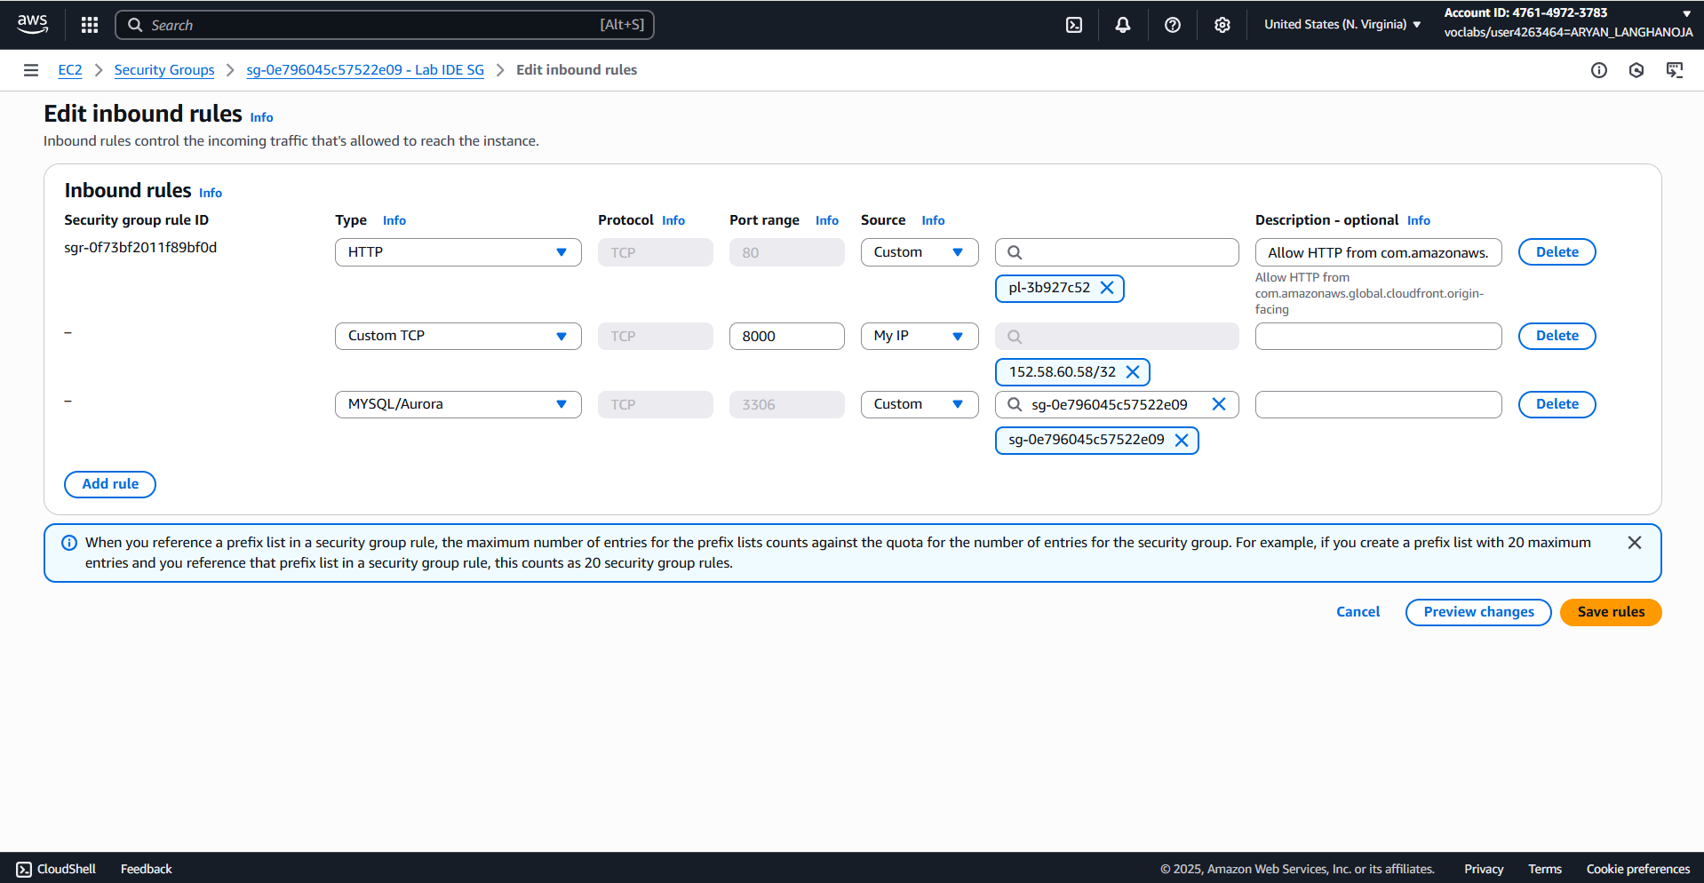Choose **Save rules**.

1. Locate the public IP address of your VS Code IDE.
   * In the left navigation pane, choose Instances.
   * Choose the Lab IDE.
   * In the bottom pane, choose the Details tab, and copy the Public IPv4 address value to your clipboard.
2. In a new browser tab, paste the \http://<<Public IPv4 address:8000>> in the address bar.

Note: The port being used here is 8000. Ensure that the protocol is http (and not https).

The coffee suppliers web application displays.

**Task 6: Creating the application database objects**

1. Connect to the Amazon RDS query editor.

* Return to the AWS Management Console browser tab.
* In the search box to the right of **Services**, search for and choose **RDS**.
* In the left navigation pane, choose **Query Editor**, and configure the following:
  + **Database instance or cluster:** Choose **supplierdb**
  + **Database username:** Choose **Add new database credentials**
  + **Enter database username:** Enter admin
  + **Enter database password:** Enter coffee_beans_for_all
  + **Enter the name of the database or schema - (optional):** Enter suppliers
  + Choose **Connect to database**.

📓 **Note:** If you receive an error message, choose **Connect to database** again and the connection should be successful.

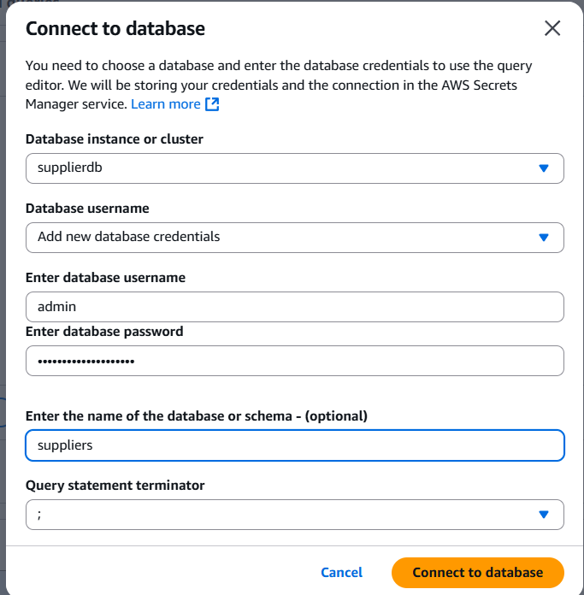

1. Create the database objects that support the coffee suppliers application.

* On the Editor tab, delete the contents of the text area, and paste in the following code:

**CREATE USER "nodeapp" IDENTIFIED WITH mysql_native_password BY "coffee";**

**CREATE DATABASE COFFEE;**

**USE COFFEE;**

**GRANT SELECT, INSERT, UPDATE, DELETE, CREATE, DROP, RELOAD, PROCESS, REFERENCES, INDEX, ALTER, SHOW DATABASES, CREATE TEMPORARY TABLES, LOCK TABLES, EXECUTE, REPLICATION SLAVE, REPLICATION CLIENT, CREATE VIEW, SHOW VIEW, CREATE ROUTINE, ALTER ROUTINE, CREATE USER, EVENT, TRIGGER ON *.* TO 'nodeapp'@'%' WITH GRANT OPTION;**

**CREATE TABLE suppliers(**

**id INT NOT NULL AUTO_INCREMENT,**

**name VARCHAR(255) NOT NULL,**

**address VARCHAR(255) NOT NULL,**

**city VARCHAR(255) NOT NULL,**

**state VARCHAR(255) NOT NULL,**

**email VARCHAR(255) NOT NULL,**

**phone VARCHAR(100) NOT NULL,**

**PRIMARY KEY ( id ));**

* Choose Run.

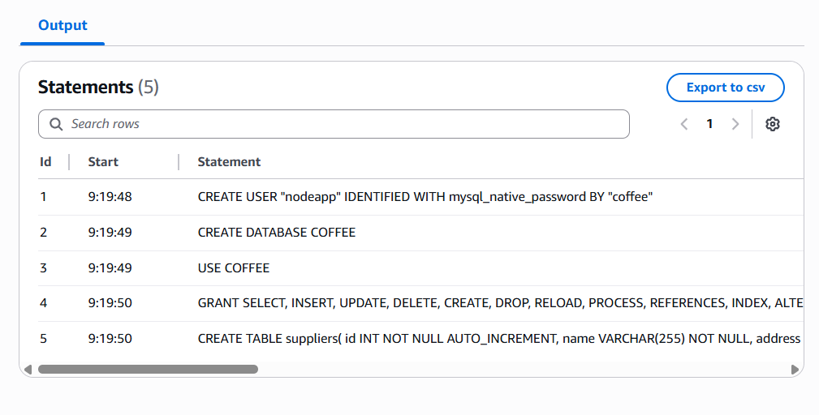

1. Verify that the suppliers table is empty.

* Replace the contents in the text area with the following code:

**use COFFEE;**

**select * from suppliers**

* Choose Run.

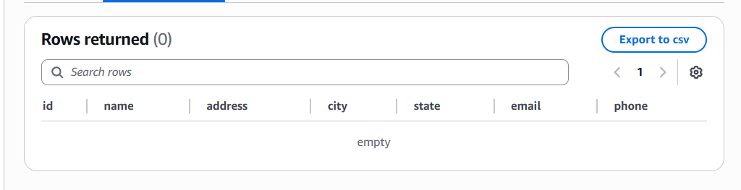

**Task 7: Seeding the database with supplier data**

1. Review the supplier data.

* Return to the VS Code IDE browser tab.
* To change the directory to resources, run the following command:

**cd ~/environment/resources**

* From the Environment pane in IDE, open the resources/coffee_db_dump.sql file and review its contents.

1. Connect to the database.

* Run the following command in the terminal window. Replace **<db-endpoint>** with the **Database endpoint** value from your text editor.

**mysql -h <db-endpoint> -P 3306 -u admin -p**

* When prompted for the password, enter coffee_beans_for_all
* The output looks similar to the following:

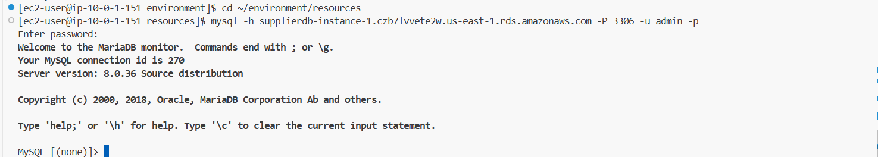

1. To verify that you are connected to the correct database, run the following command:

**use COFFEE; select * from suppliers;**

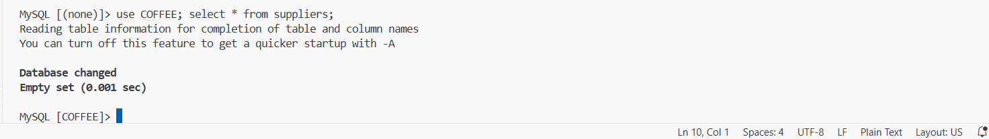

1. To use the SQL dump to update your database with the information from the supplier, run the following command at the mysql prompt:

**source coffee_db_dump.sql**

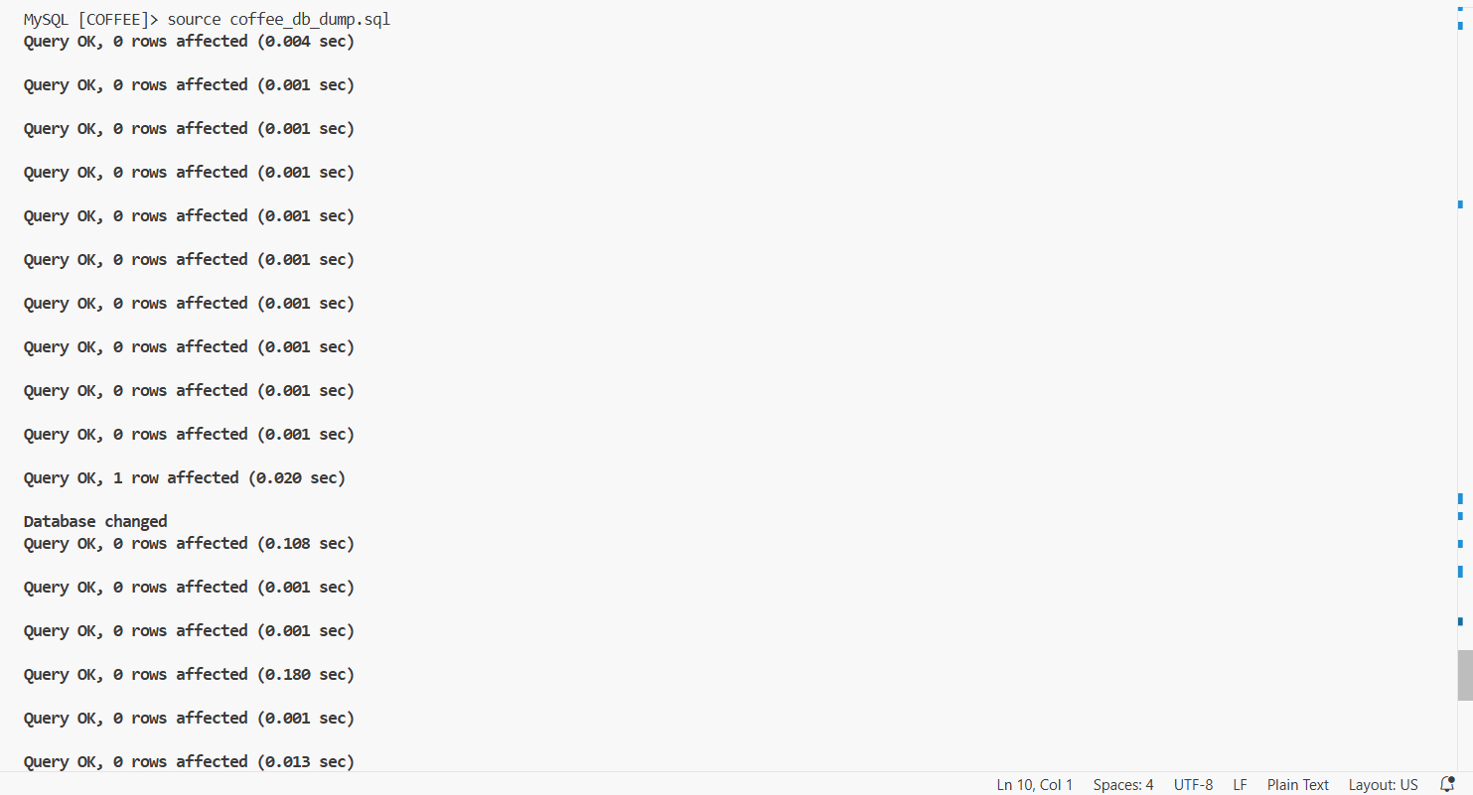

1. Review the data that was loaded into the database.

* To query the suppliers table, run the following command at the mysql prompt:

**use COFFEE; select * from suppliers;**

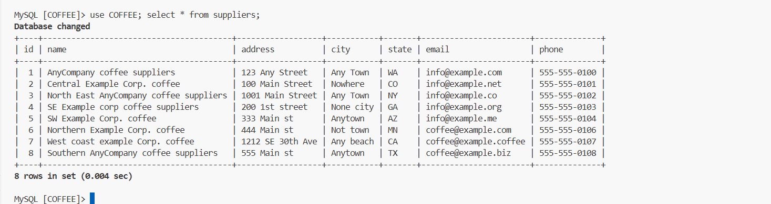

* To query the *beans* table, run the following command at the mysql prompt:

select * from beans;

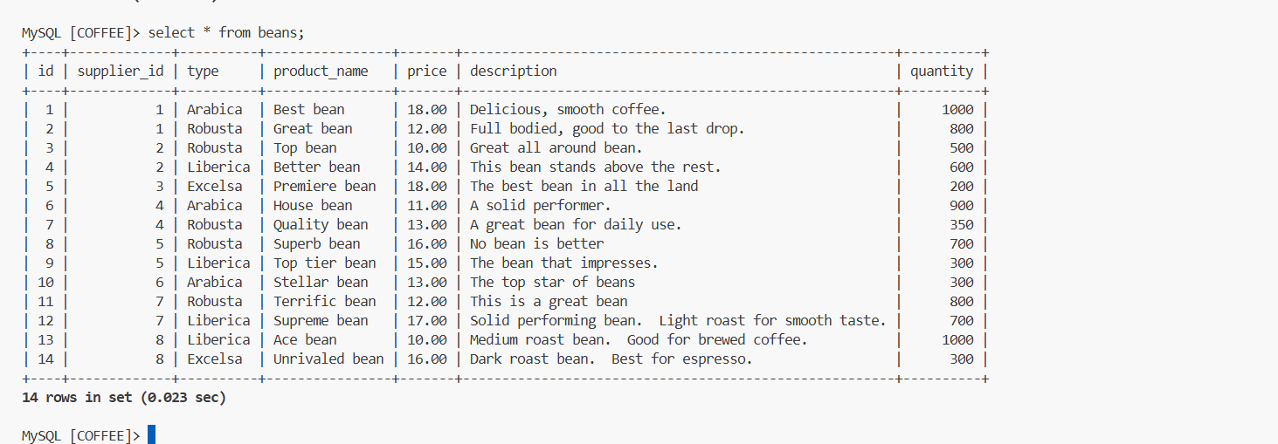

**Task 8: Review the IAM policy and role for Elastic Beanstalk**

1. Review the Elastic Beanstalk IAM policy that will be used with your Docker environment.

* Return to the AWS Management Console browser tab.
* From the **Services** menu, choose **IAM**.
* In the left navigation pane, choose **Policies**.
* In the search text box, enter aws-elasticbeanstalk-ec2-instance-policy then select the hyperlink of the policy.

**Task 9: Creating an Elastic Beanstalk application**

1. Create a sample Elastic Beanstalk application.

* Return to the VS Code IDE browser tab.
* To change to the *environment* directory, run the following command:

**cd ~/environment**

* To create a new folder called *bean*, run the following command:

**mkdir bean**

* To change to the *bean* directory, run the following command:

**cd bean**

* To create a sample application named *MyNodeApp*, run the following command:

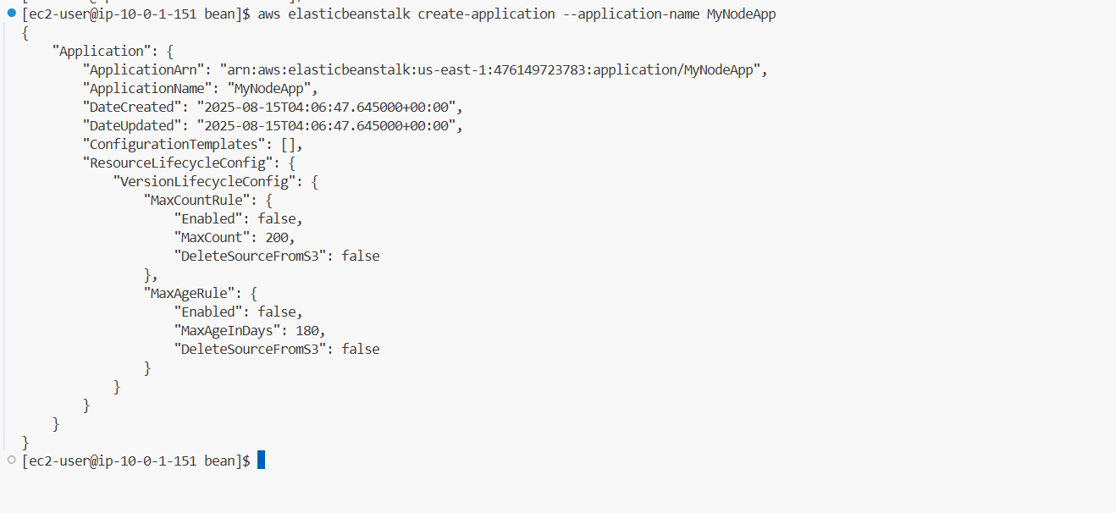**aws elasticbeanstalk create-application --application-name MyNodeApp**

1. Create an Elastic Beanstalk environment.

* In VS Code IDE, in the *bean* folder, create a new file named *options.txt* and open it.
* Paste the following text into the *options.txt* file:

1. To identify the currently available solution stack for Amazon Linux 2, run the following command in the VS Code bash terminal:

**aws elasticbeanstalk list-available-solution-stacks|grep 'running Docker'**



* Run the following command. Replace the <solution-stack-name> placeholder with the name of the available solution stack:

**aws elasticbeanstalk create-environment --application-name MyNodeApp --environment-name MyEnv --solution-stack-name "<solution-stack-name>"  --region us-east-1 --option-settings file://options.txt**

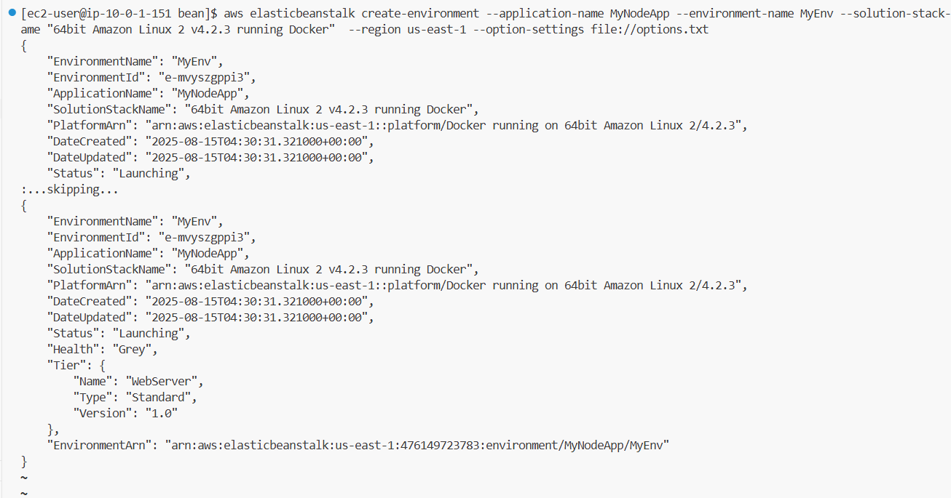

1. To stop the Docker container that is running on the VS Code IDE, run the following command:

**docker stop node-web-app-1 && docker rm node-web-app-1**

1. Review your Elastic Beanstalk environment in the AWS Management Console.

* Return to the AWS Management Console tab.
* From the **Services** menu, choose **Elastic Beanstalk**.
* For the **MyEnv** environment, the **Health** displays *Pending*.
* At the bottom under the **Events** tab.

1. Update the application with the code for the coffee suppliers application.

* The code is in the image that you uploaded to Amazon ECR. For now, you will deploy the application to Elastic Beanstalk manually. In a later lab, you will learn to automate deployments.
* On your local computer, create a new text file called *Dockerrun.aws.json*.
* Paste the following text into the file:

**{**

**"AWSEBDockerrunVersion": "1",**

**"Image": {**

**"Name": "<FMI_1>",**

**"Update": "true"**

**},**

**"Ports": [ { "ContainerPort" : 3000 } ]**

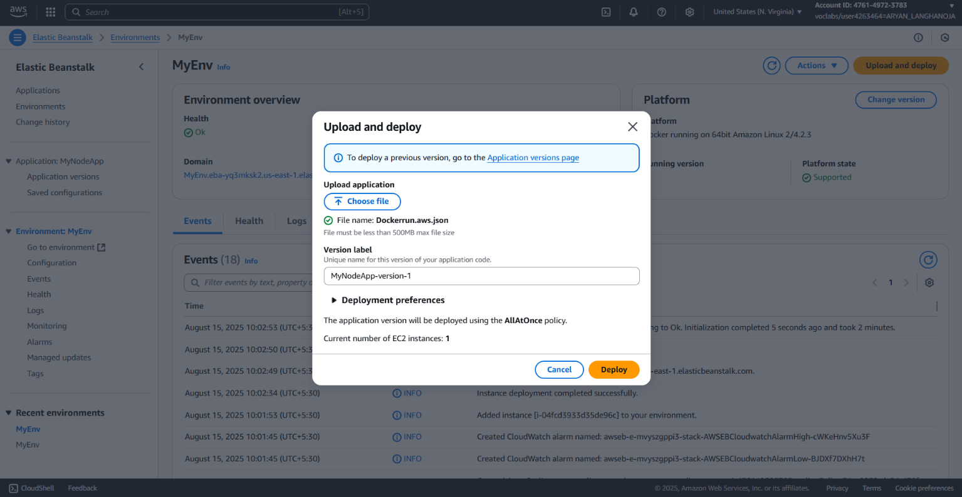

1. In the file, replace the **<FMI_1>** placeholder with the **Repository URI** value from your text editor.

* Save the changes to the file.
* Return to the AWS Management Console browser tab.
* On the **MyEnv** environment page within the Elastic Beanstalk console, choose **Upload and deploy**.
* Navigate to and choose the *Dockerrun.aws.json* file.
* For **Version label**, append the letter a to the default MyNodeApp-version-1
* Keep the current deployment preferences.
* Choose **Deploy** and observe the deployment process.
* If you want to follow what is happening, observe the **Recent events** section.

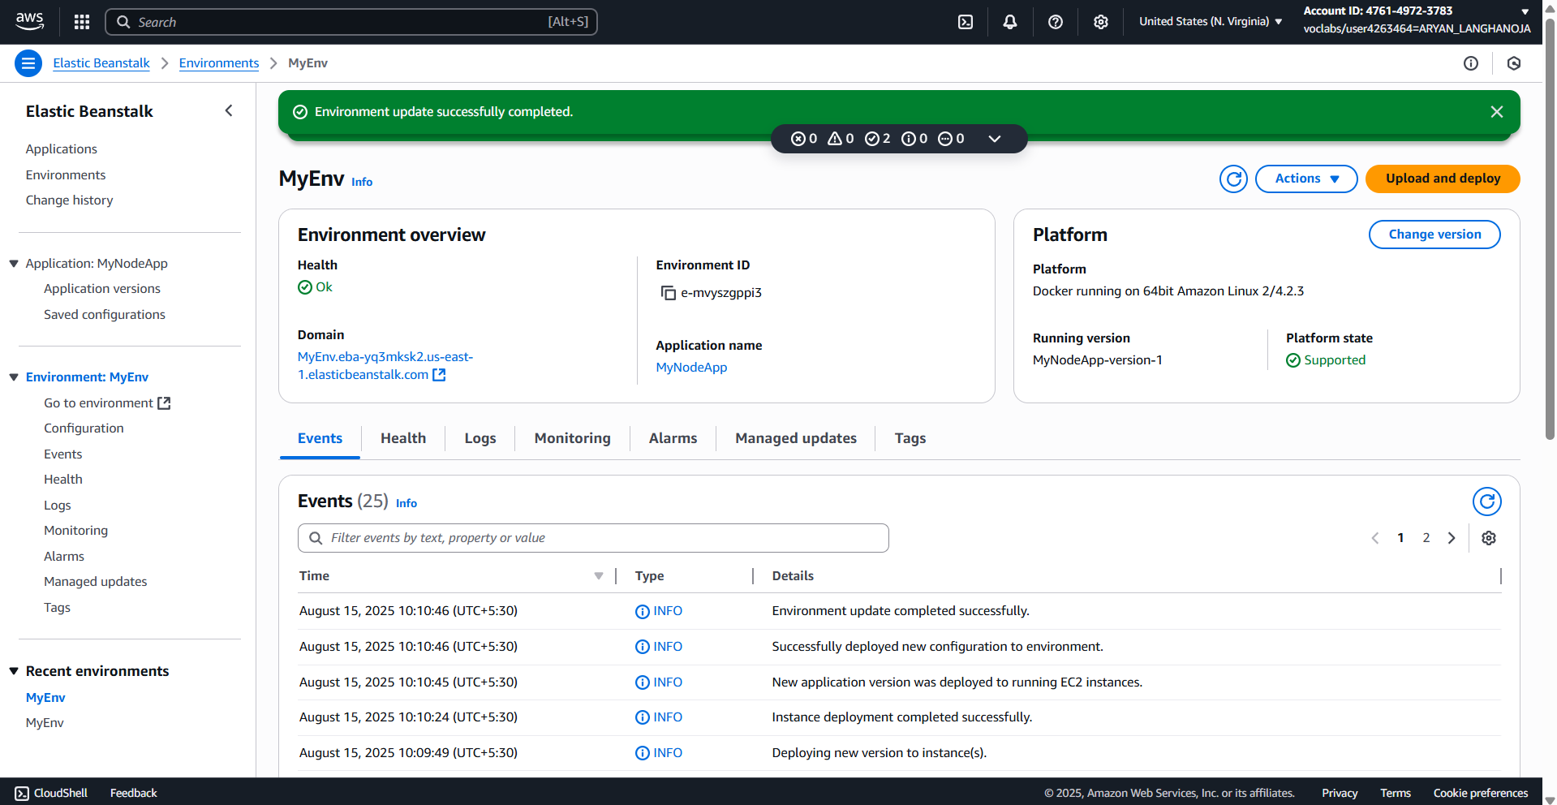

**Task 10: Configuring the API Gateway proxy**

1. Create an API Gateway resource.

* Return to the AWS Management Console browser tab.
* From the **Services** menu, choose **API Gateway**.
* Choose the **ProductsApi** hyperlink.
* Choose **Create resource**, and configure the following:
  1. **Resource Path:** Keep the default / selection
  2. **Resource Name:** Enter bean_products

💁‍♂ **Note:** Ensure the resource name value has an underscore.

* 1. Select **CORS (Cross Origin Resource Sharing)**

📓 **Note:** CORS is required to enable communication between your website and the endpoint.

* 1. 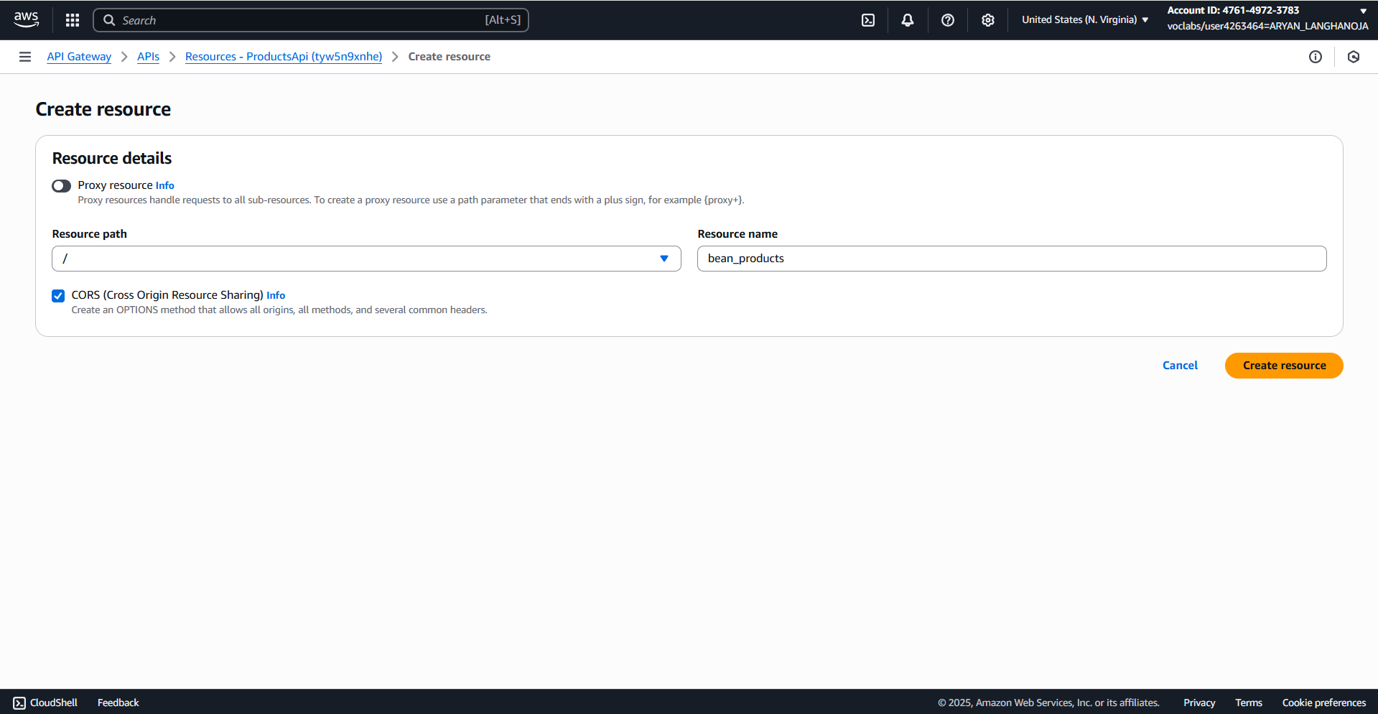Choose **Create resource**.

1. Create an API Gateway method.

* In the Methods panel, choose **Create method**.
* For **Method type** choose **GET**.
* Configure the following:
  1. **Integration type:** Choose **HTTP**
  2. Toggle **HTTP proxy integration** to **on**
  3. For **HTTP method** choose **GET**
  4. For **Endpoint URL**, enter the following. Replace the **<FMI_1>** placeholder with the Elastic Beanstalk URL from your text editor:

URL :- http://myenv.eba-yq3mksk2.us-east-1.elasticbeanstalk.com/beans.json

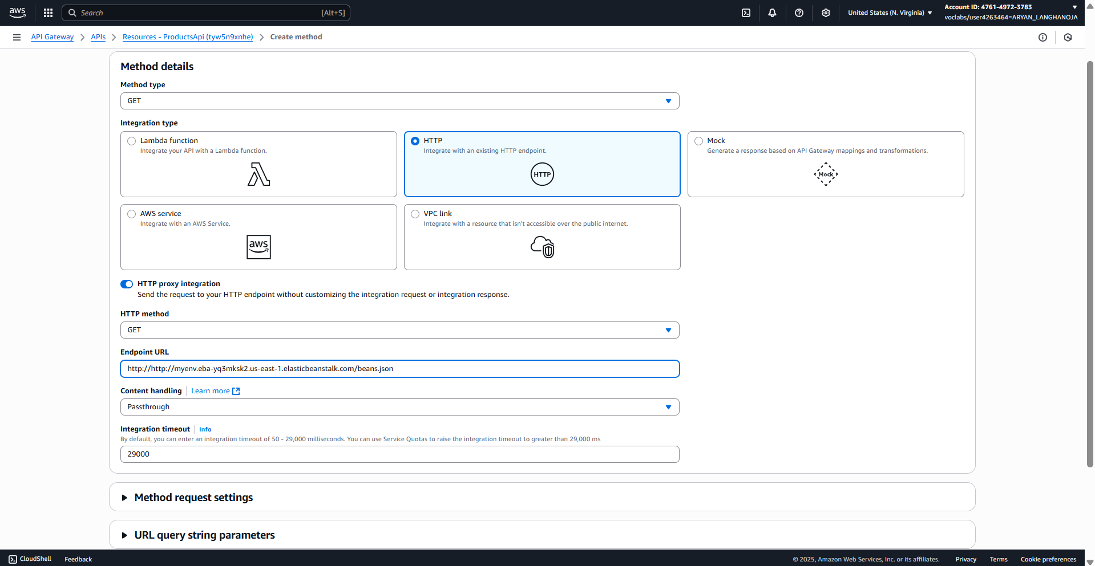

* + Choose Create method.
* 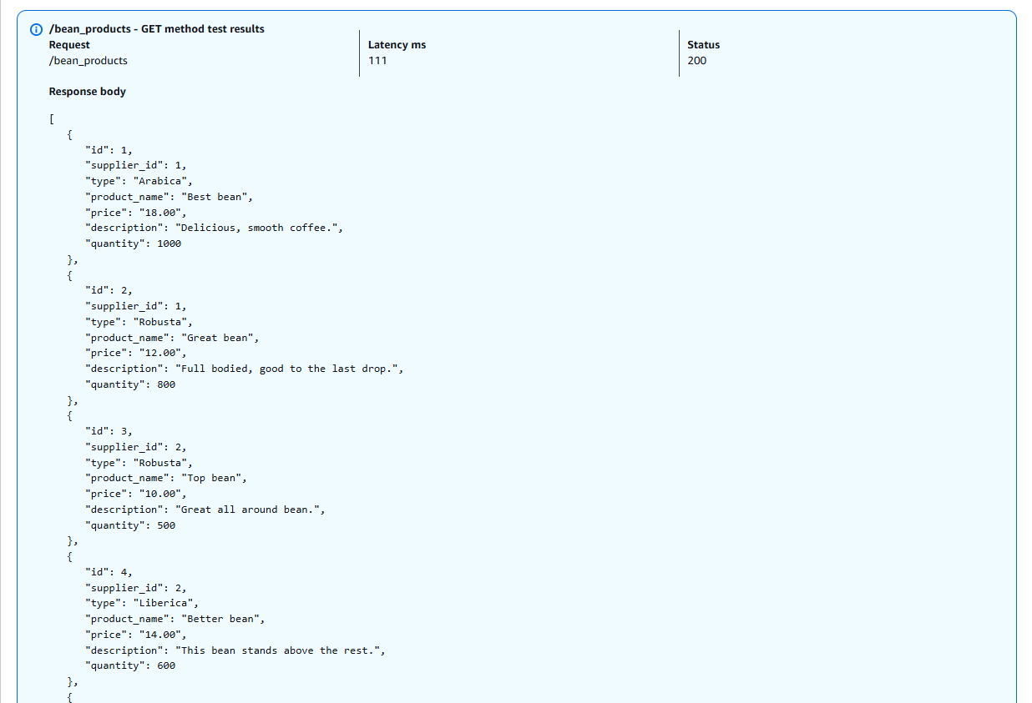Choose the Test tab.

1. Deploy the API changes.

* In the **Resources** pane, choose the top-level "/" resource.
* Choose **Deploy API**.
* For **Stage**, choose **prod**.
* Choose **Deploy**.

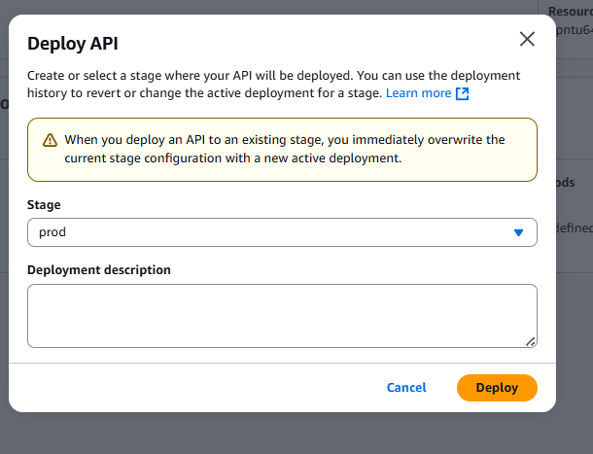

**Conclusion:-**

In this lab,

* I deployed the coffee suppliers app on AWS using Aurora Serverless for the database and Elastic Beanstalk for the web app.
* I downloaded the code,
* upgraded AWS CLI,
* set up VPC subnets,
* created the Aurora DB, and
* connected it to the Docker container.
* I created database tables, loaded sample data, and reviewed the ECR image.
* Then, I deployed the app to Elastic Beanstalk using Dockerrun.aws.json and linked it with API Gateway.
* The app now runs successfully with managed services, scalable, and accessible via an API endpoint.

**Result :-**

